**MY ONLINE SHOPPING STORE**

We have a physical shopping store, which is doing well in terms of revenue and margin. We want to increase the business by extending the availability of our products through online mechanisms. Quick time-to-market is the main criteria;

we are adding some features:

1) Home Page

2) Product Search facility

3) Product Detail Page

4) Add to Cart

5) Place Order

**Preliminary Design:**

User

Admin

## Specification of Use Cases

### Use Case Search Product Details

|  |  |
| --- | --- |
| Search Product Details | |
| Element | Details |
| Actor | User |
| Trigger | With or without authentication |
| Pre Conditions | A text box provided for entering the category name |
| Post Conditions | On clicking the Search button products of that category are displayed in products page. |
| Normal course | 1. Use the Category Name to search the products |

### Use Case Products

|  |  |
| --- | --- |
| Products | |
| Element | Details |
| Actor | User |
| Trigger | On clicking the search button after entering the category then the lsit of products in that category are displayed. |
| Pre Conditions | Entering the category in the text box and clicking the search button |
| Post Conditions | The various Products of the searched category are displayed |
| Normal course | 1. User enters the Product category 2. The various Products in that category are displayed |

### Use Case View Product

|  |  |
| --- | --- |
| View Product | |
| Element | Details |
| Actor | User |
| Trigger | On clicking a particular item the information about the product is to be displayed. |
| Pre Conditions | The user needs to click the image to get the complete details of a product |
| Post Conditions | The information regarding a product is to be displayed |
| Normal course | 1. User clicks the image to get details 2. The fetched records are displayed |

### Use Case Add Product

|  |  |
| --- | --- |
| Add Product | |
| Element | Details |
| Actor | Admin |
| Trigger | When the Quantity is not available |
| Pre Conditions | Item details are entered |
| Post Conditions | The details are stored in the database |
| Normal course | 1. Admin enters the details of the new products 2. They are stored in the database |

### Use Case Delete Product

|  |  |
| --- | --- |
| Delete Product | |
| Element | Details |
| Actor | Admin |
| Trigger | When there is no availability of a product the admin can delete the products from database |
| Pre Conditions | Check the out of stock products and expired products |
| Post Conditions | The Products that are out of stock and expired Products are removed from the database |
| Normal course | 1. Admin login using his credentials 2. Search for the product to be deleted 3. Deletes the particular product |

### Use Case Edit Product

|  |  |
| --- | --- |
| Edit Product | |
| Element | Details |
| Actor | Admin |
| Trigger | When the product needs to be updated |
| Pre Conditions | The product may vary in its cost and delivery charges time to time |
| Post Conditions | The product has been updated regarding the latest information |
| Normal course | 1. Admin logins using his credentials 2. Updates the selected products in the database. |

### Use Case Add To Cart

|  |  |
| --- | --- |
| Add To Cart | |
| Element | Details |
| Actor | User |
| Trigger | When user wants to buy or save it for future purchase he will add to cart and store it |
| Pre Conditions | If the user likes a particular product he can choose by clicking the Add To Cart |
| Post Conditions | The selected items are available later in the cart and can buy in future if stock is available |
| Normal course | 1. User selects the particular product 2. He then clicks on Add To Cart. 3. The cart items are available for later usage |

### Use Case Place Order

|  |  |
| --- | --- |
| Place Order | |
| Element | Details |
| Actor | User |
| Trigger | When User clicks on Buy Now Button |
| Pre Conditions | The user will finalizes and then proceeds to place the order |
| Post Conditions | The user places the order |
| Normal course | 1. User clicks the Place Order button 2. The order is then placed |

ProductCategory

Product

CartItem

has

AddedTo

**ER Diagram**

**Database Table Design:**

**ProductCategory:**

|  |  |  |
| --- | --- | --- |
| **Field Name** | **Type** | **Remark** |
| CategoryId | Int | PK |
| CategoryName | Nvarchar(50) |  |

**Products:**

|  |  |  |
| --- | --- | --- |
| **Field Name** | **Type** | **Remark** |
| Id | int | PK |
| CategoryId | int | FK |
| Price | Float |  |
| Quantity | Int |  |
| Description | Nvarchar(Max) |  |
| Picture | Nchar(100) |  |

**CartItem:**

|  |  |  |
| --- | --- | --- |
| **FieldName** | **Type** | **Remark** |
| Id | Int | FK |
| Price | Float |  |
| Quantity | Int |  |

**Flow Chart for Online Shopping**

ProductsDetails Page

Products Page

Home Page

AddToCart Page

Place Order Page

**APPENDICES:**

1. **Home Page:**

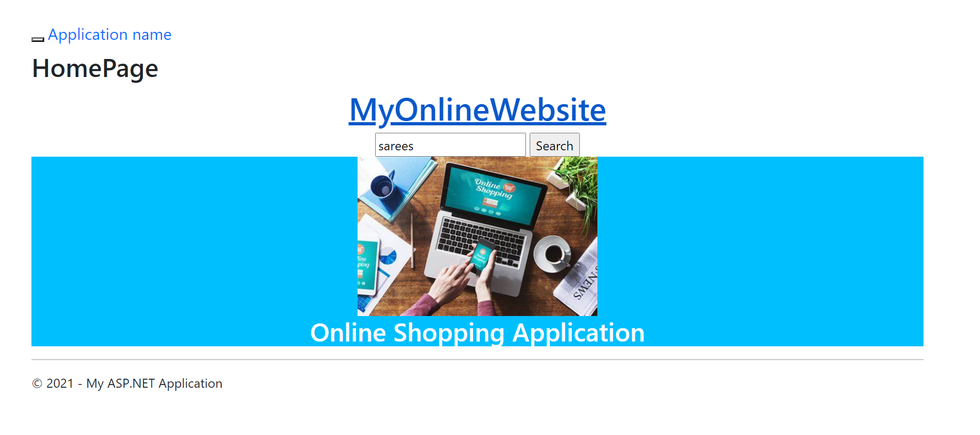

1. **List of Products:**

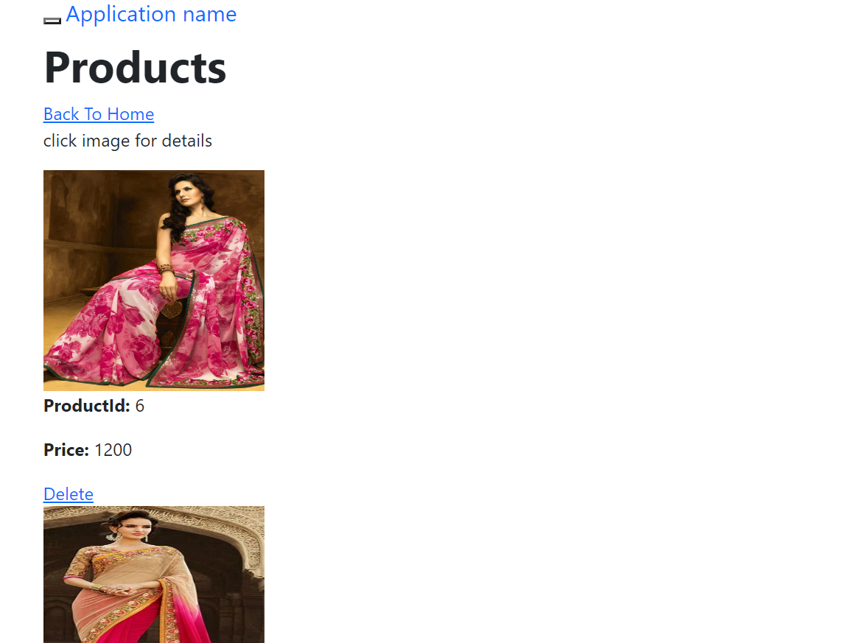

1. **Product Details:**

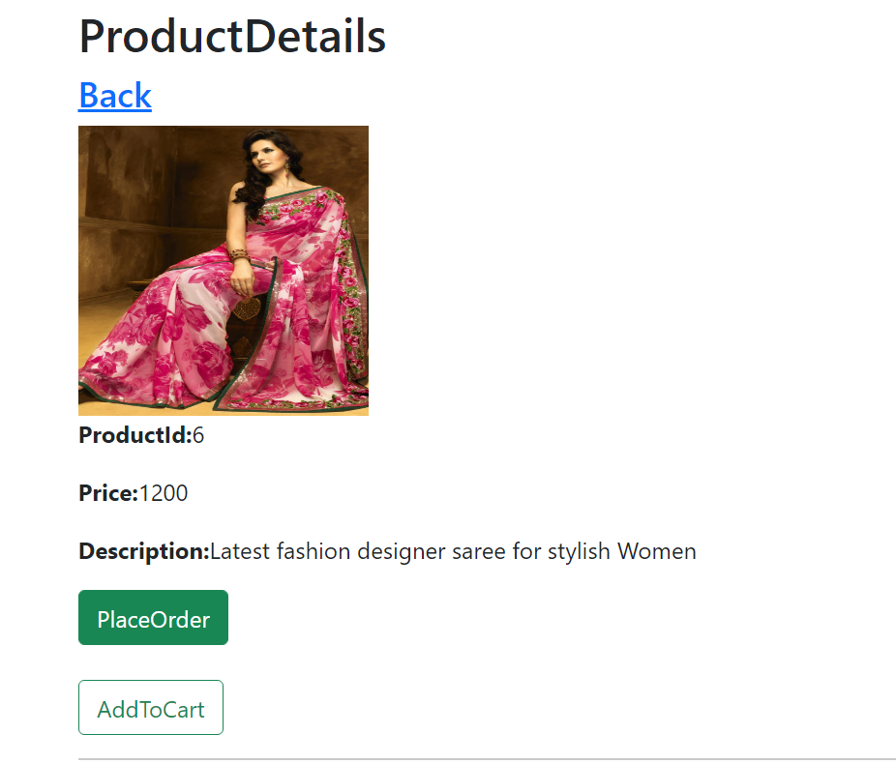

1. **Confirmation Page:**

